Power on H801RC, green light is on.
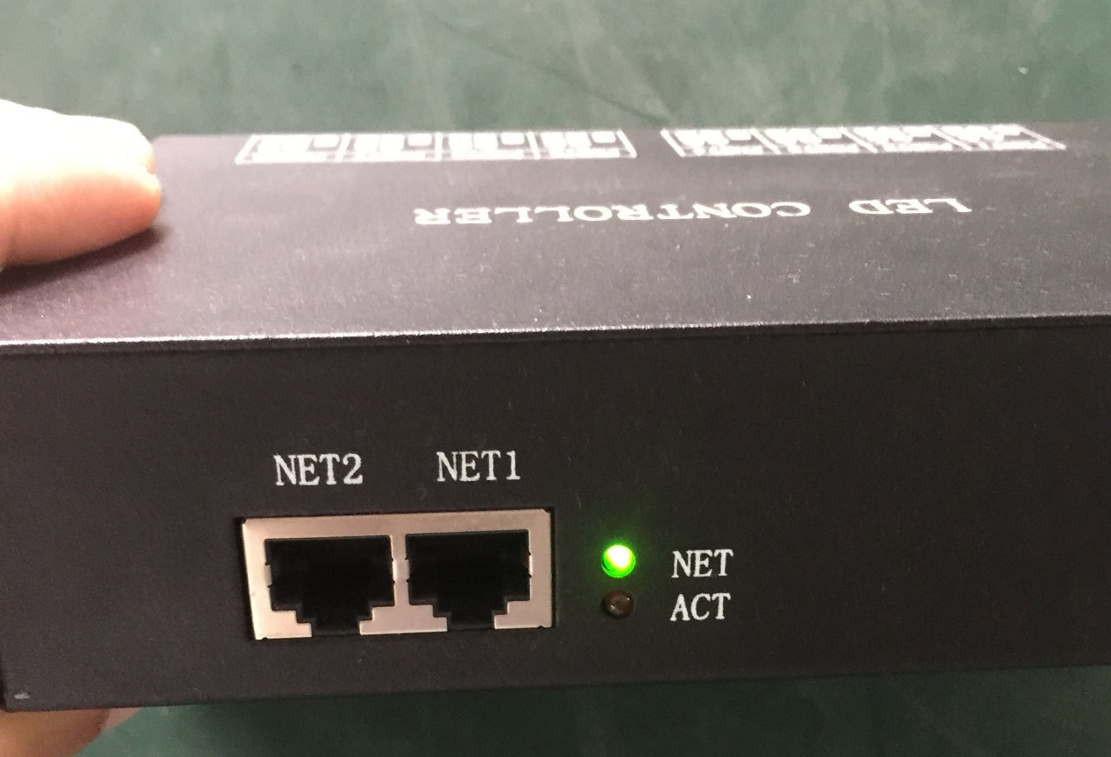
Connect NET1 to computer network interface with RJ45 cable(crossover). Green light is flashing.
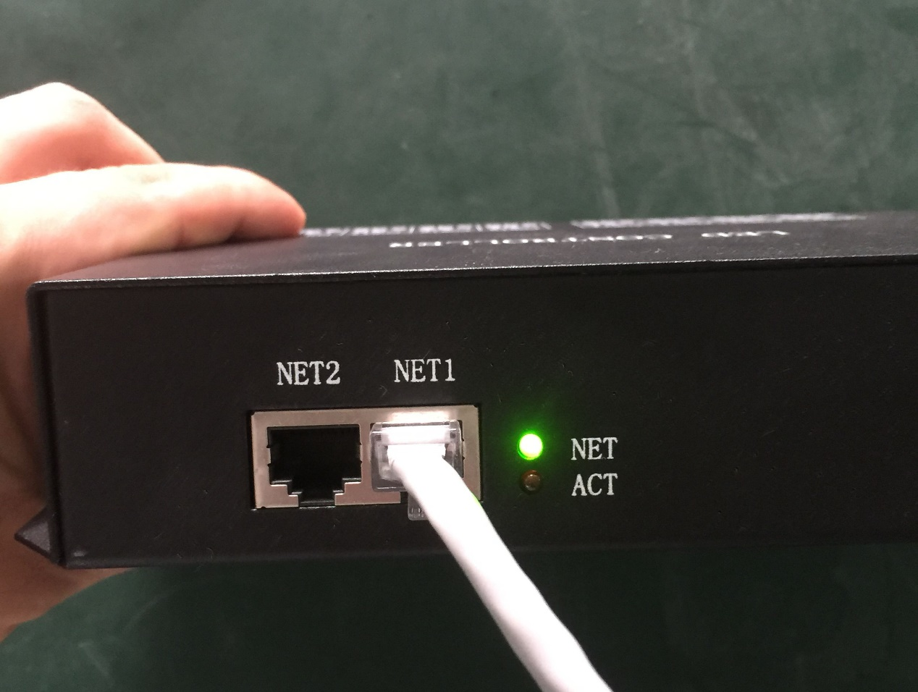
Network and Internet Setting
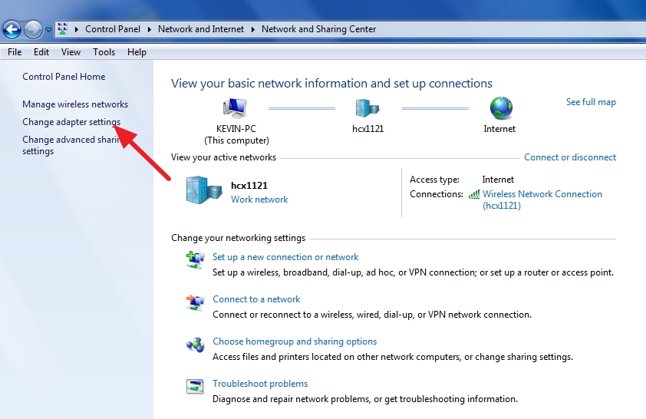
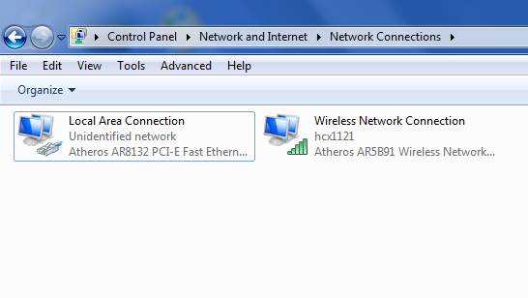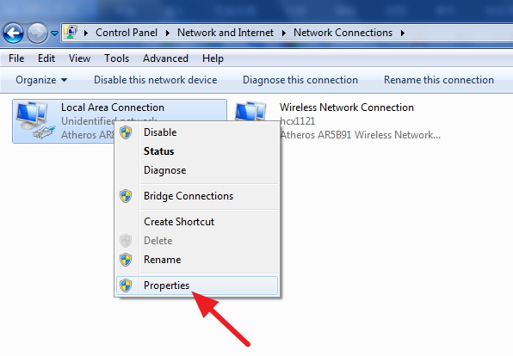
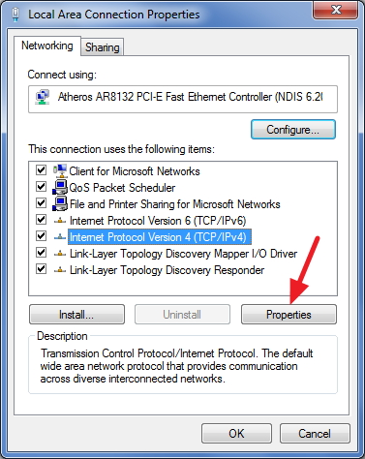
Check the option and enter number exactly the same as the following image displays, then click “OK”.
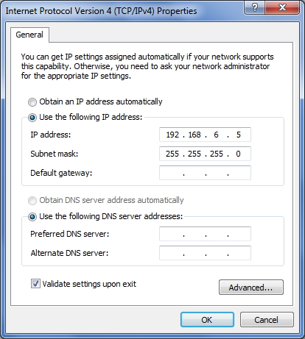
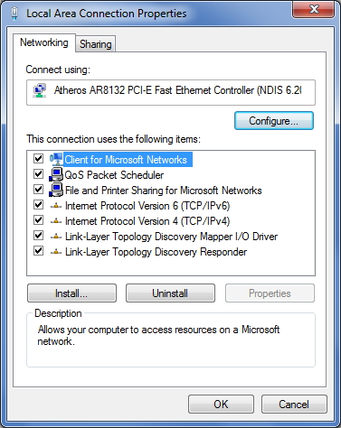
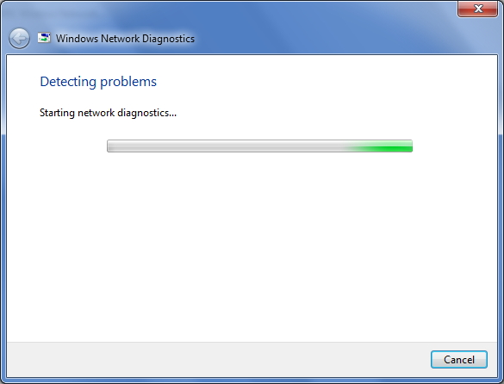
Click “close”.
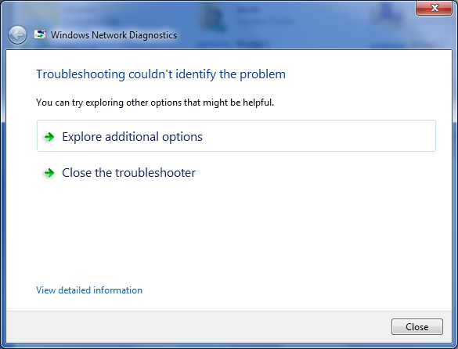
Open “LED Studio Software”, click “setting”-- “system setting”.
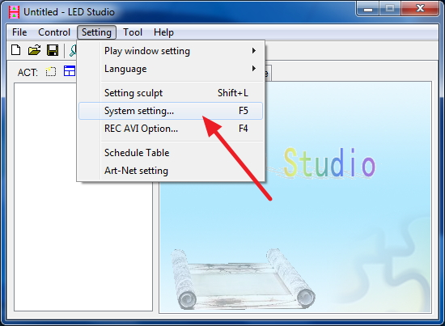
For H801RC, Hardware interface must be “Network Adapter”, if it’s not, choose “Network Adapter”, click “Apply”-- “OK”, then restart software.
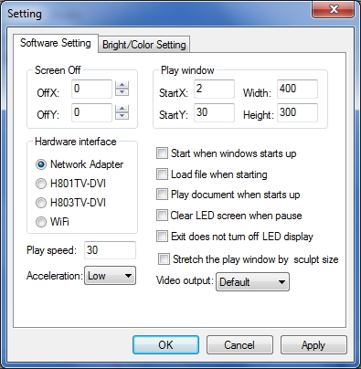
Then click “setting”-- “setting sculpt”, password is empty, click “OK” to enter sculpt setting window.
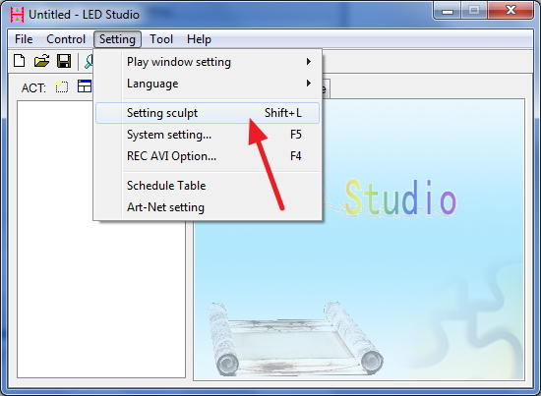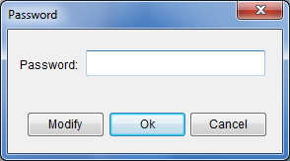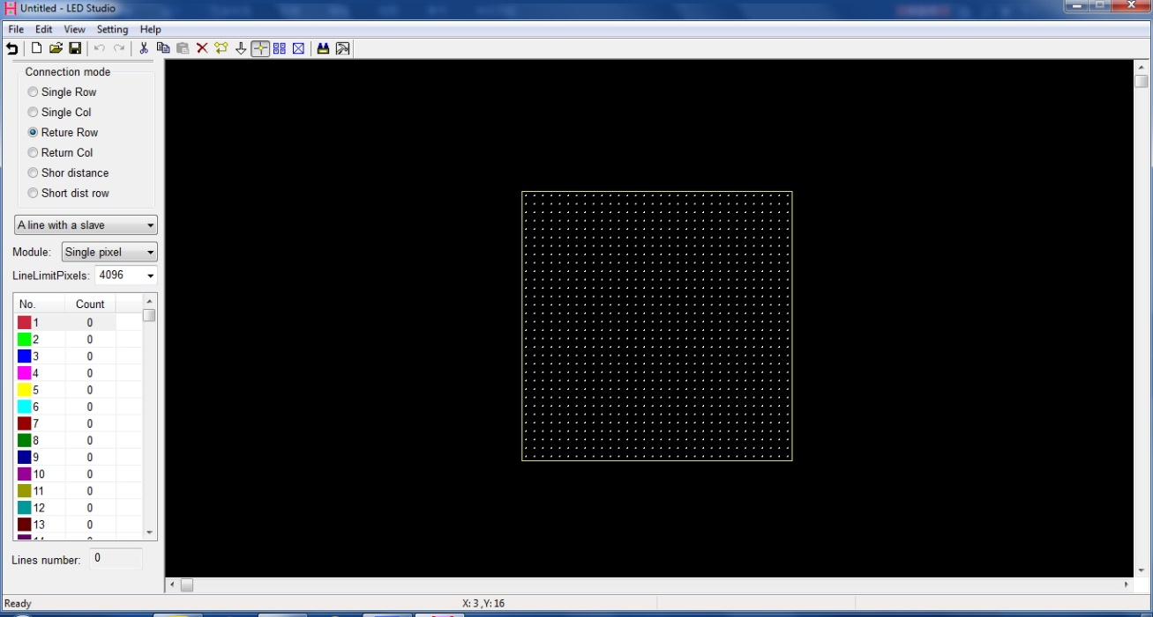
Click “File”-- “New” to create a new sculpt.
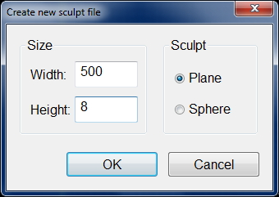
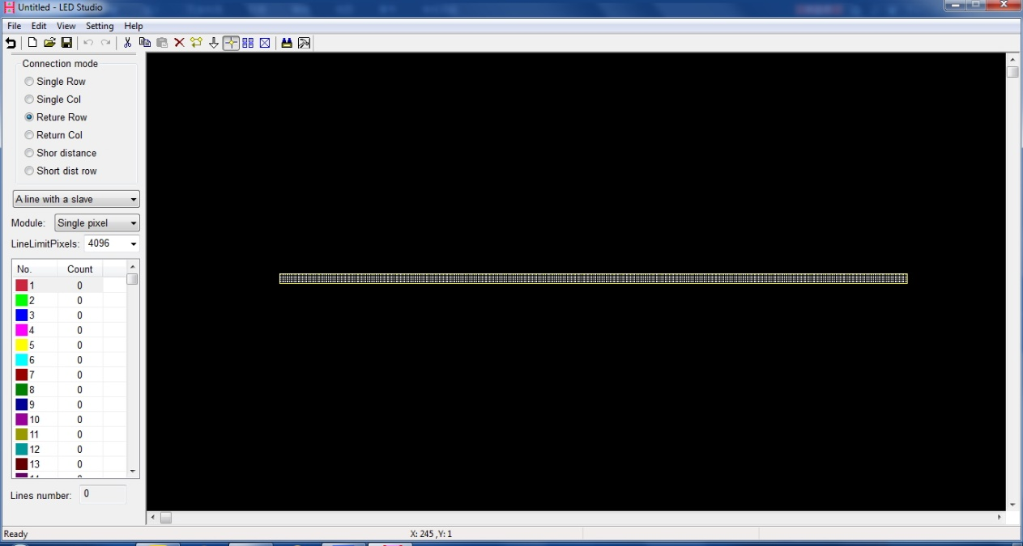
Settings:
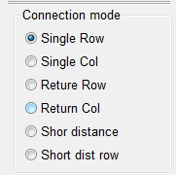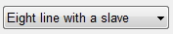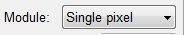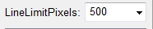
Then rectangular select the sculpt from left top corner to right bottom corner.
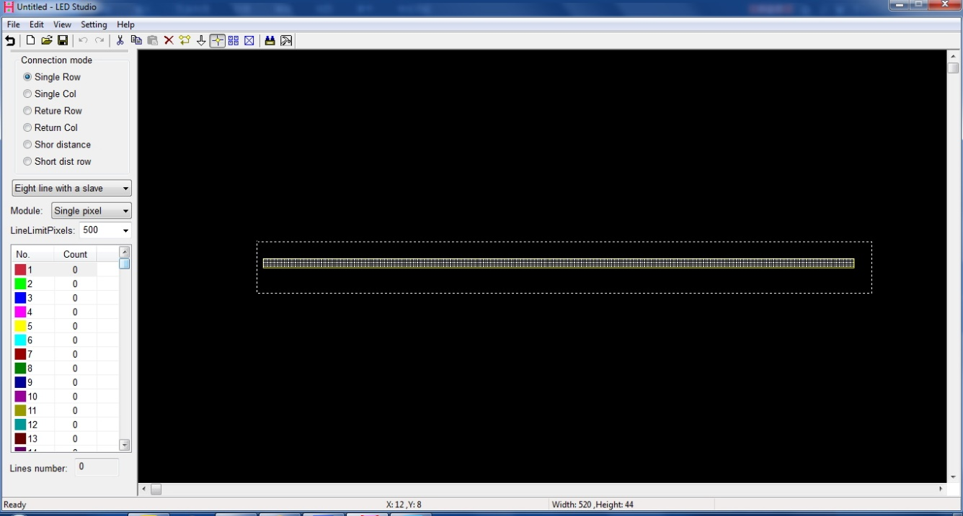
There are pixels added to the sculpt
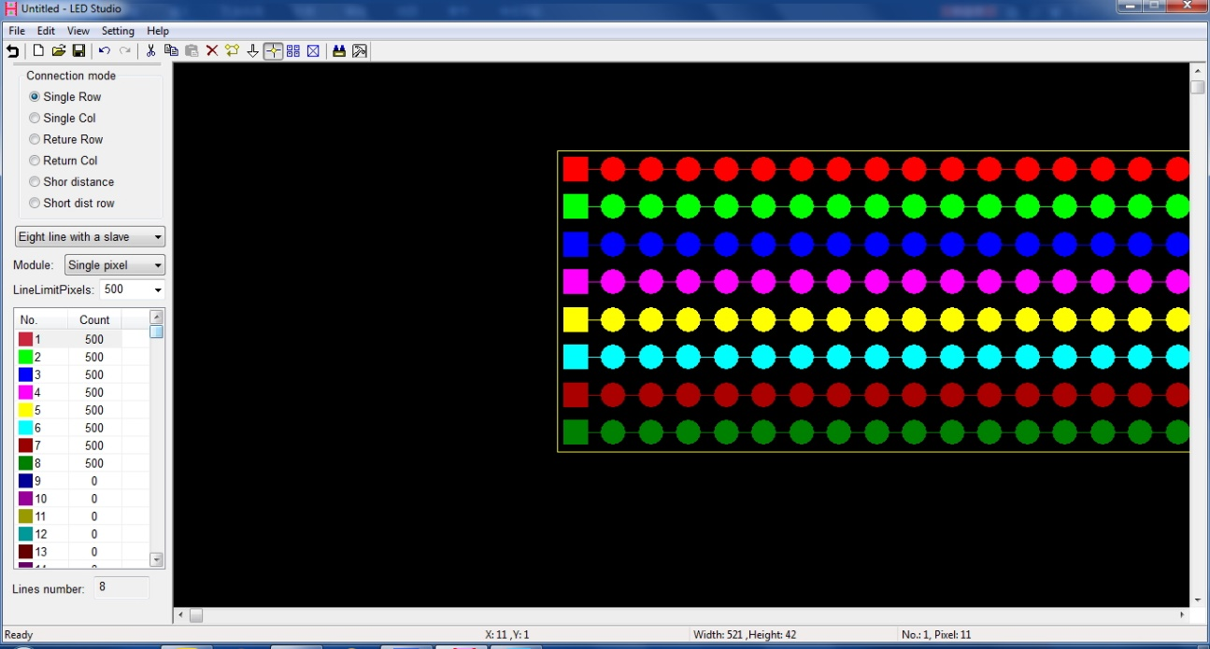
This is the pixels number of each line(port) of controller.
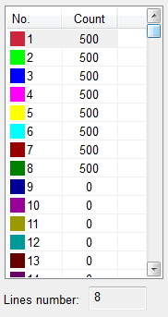
Click “Slave Setting”:
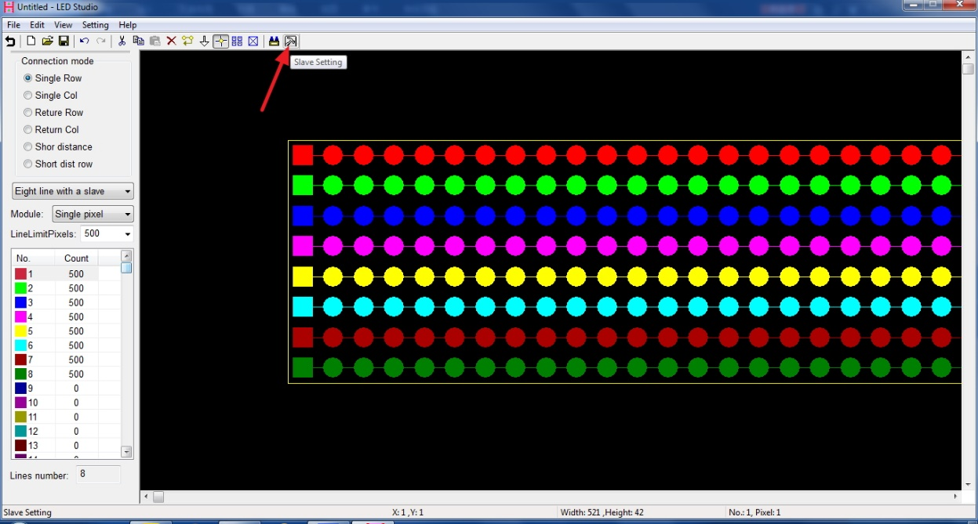
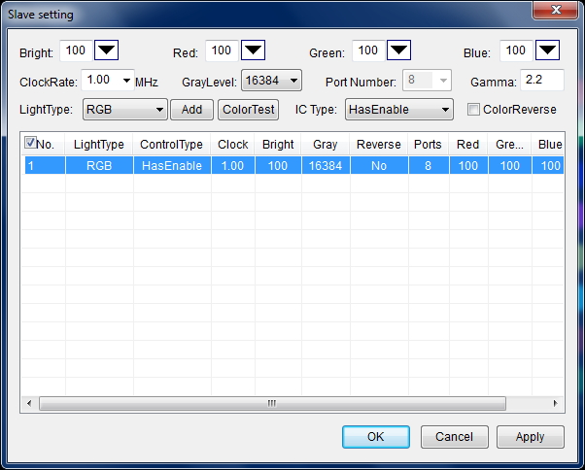
Select IC Type (many IC share the same option), Light Type, and Clock Rate. Don’t need to set others.
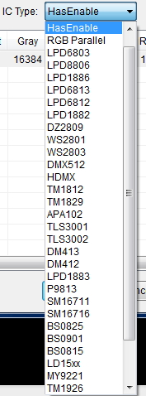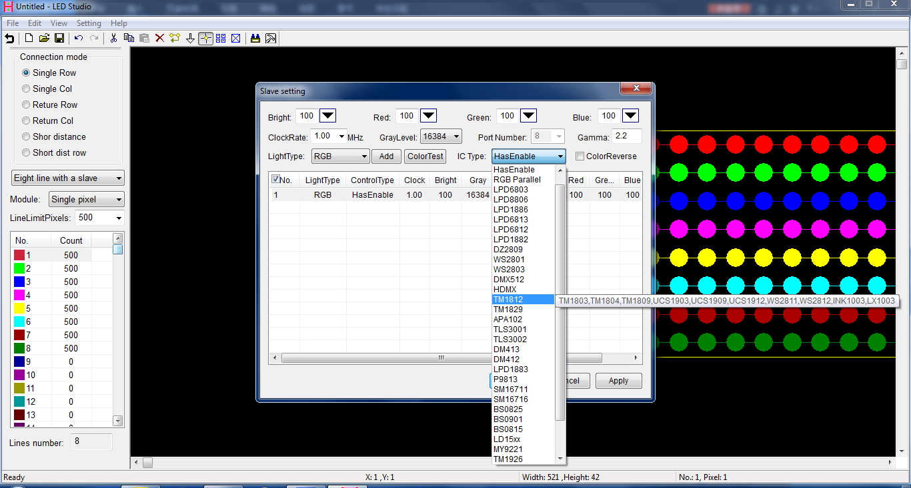
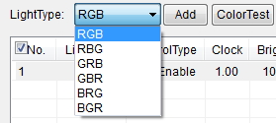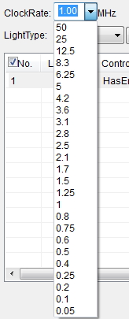
After finishing all settings, click “Apply”-- “OK” to exit slave setting.
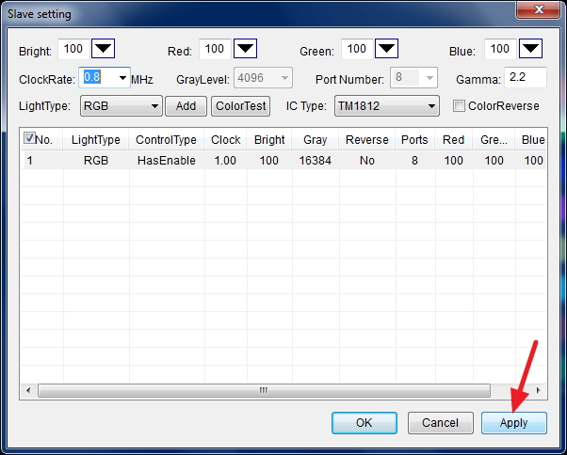
Click “Setting”-- “Multi-Net Setting”
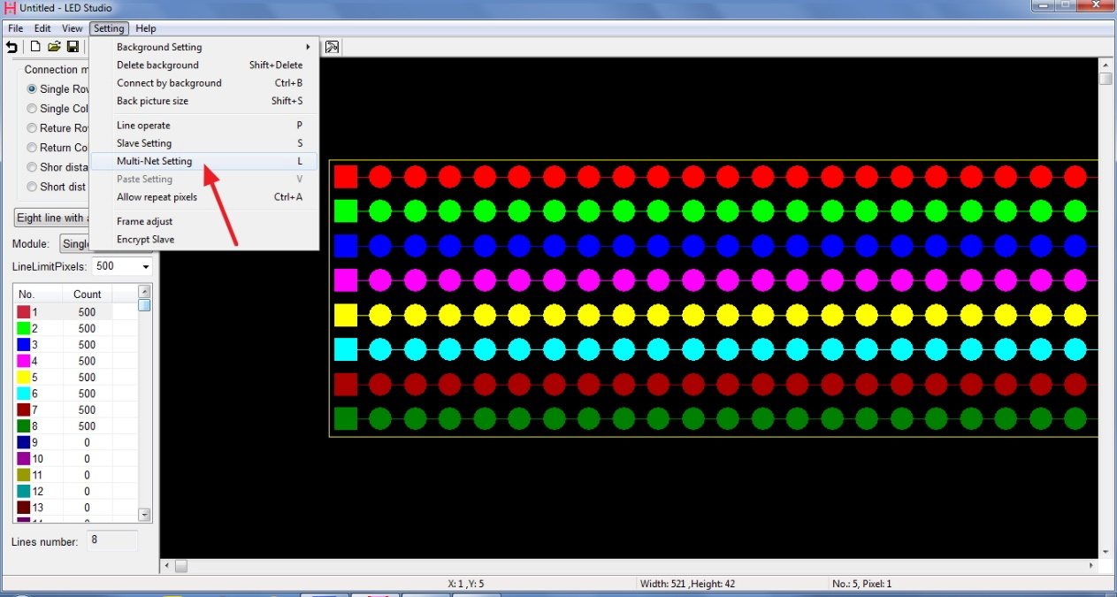
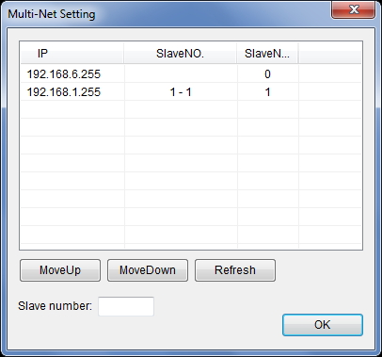
Set controller for the specified IP address:
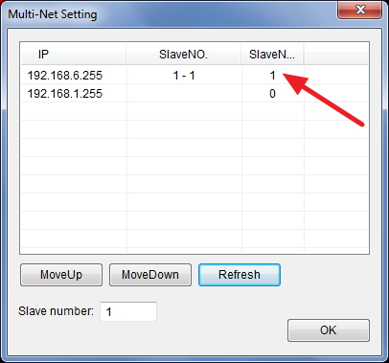
Click “Return” to return to main window. 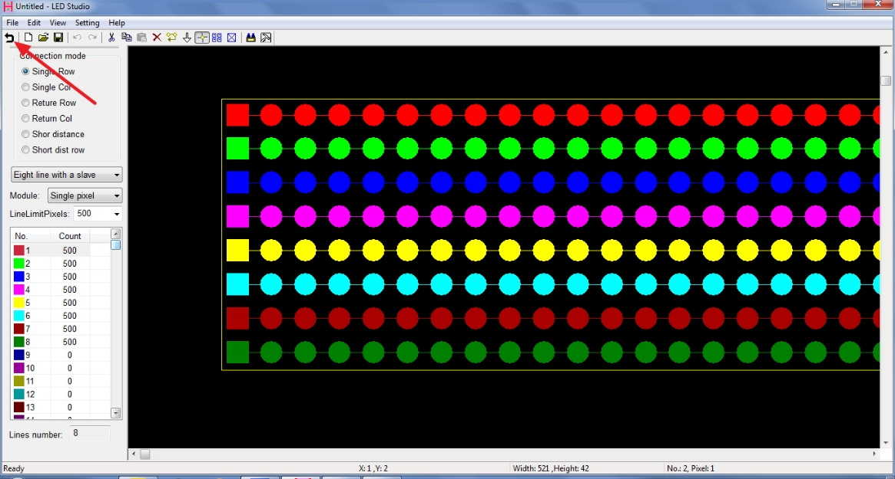
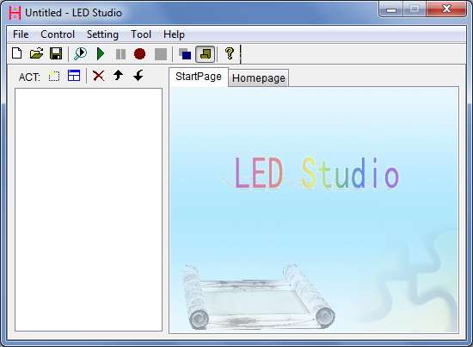
Click “Setting”-- “System Setting”
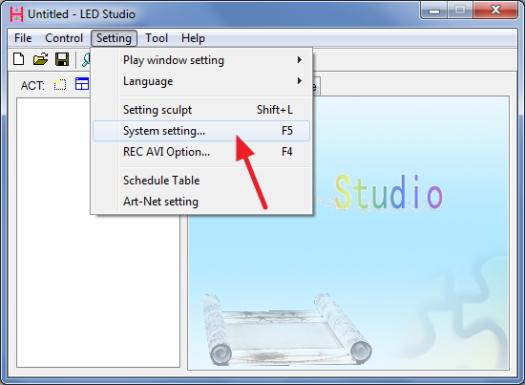
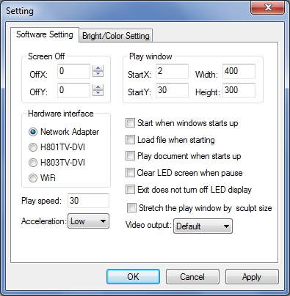
We can set StartX, StartY to 0,0. The Width and Height is the same or bigger as the size of sculpt. So here we set to 500, 8. Then click “Apply”-- “OK” to exit.
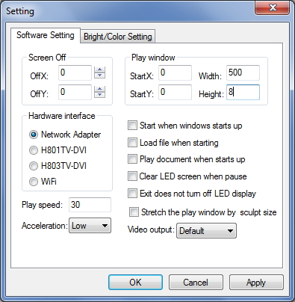
Click “New window”-- “Design window” to create a new design window.
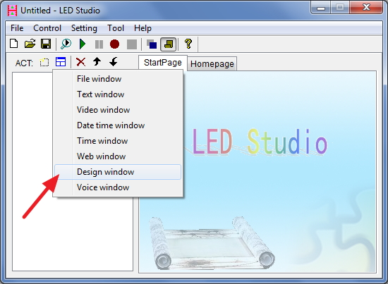
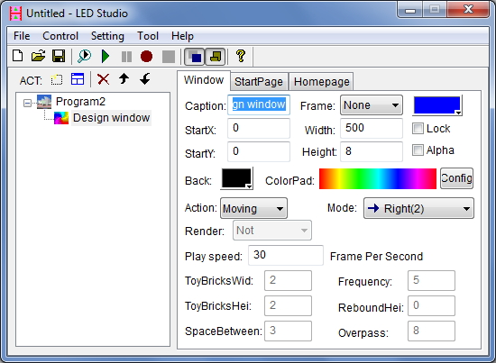
Then click “Config” to configure color.
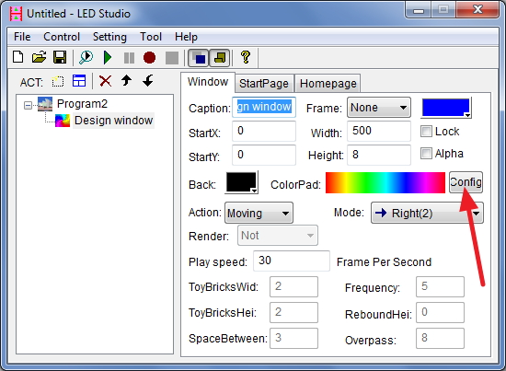
By the way, you can click “” to show or hide screen.
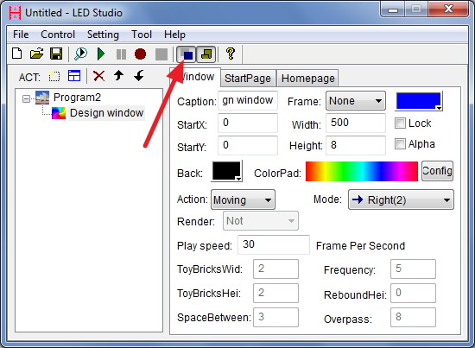
After clicking “Config”, the following displays.
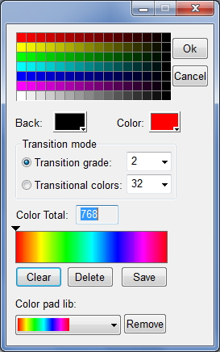
Normally, i clear the color in color plate, set transition grade to 5, and choose the second color in color pad library for test. Then click “OK” to exit.
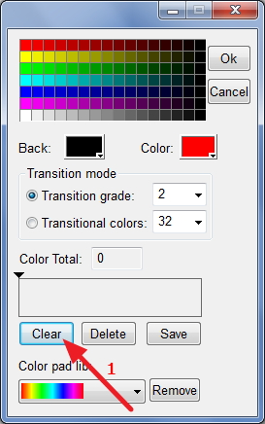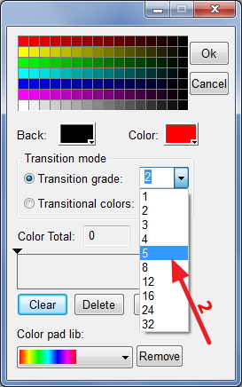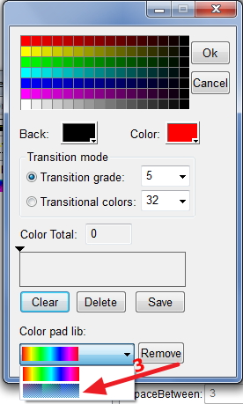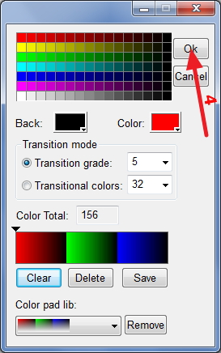
You can choose among many actions and modes. Here, i choose “Moving” and “Right”.
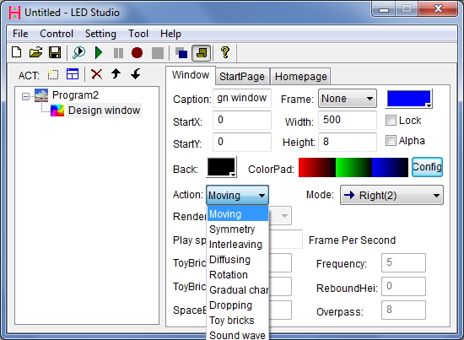
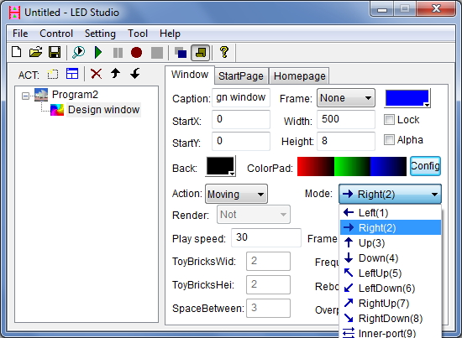
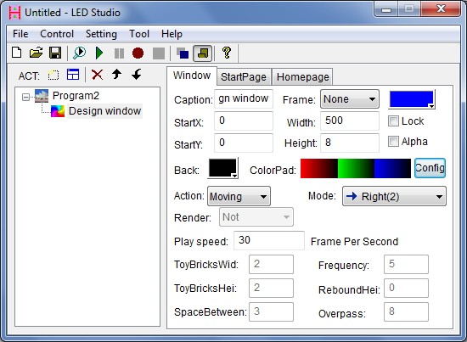
Then click “” to play the program.
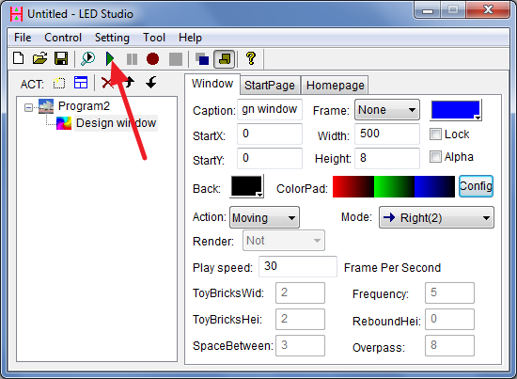
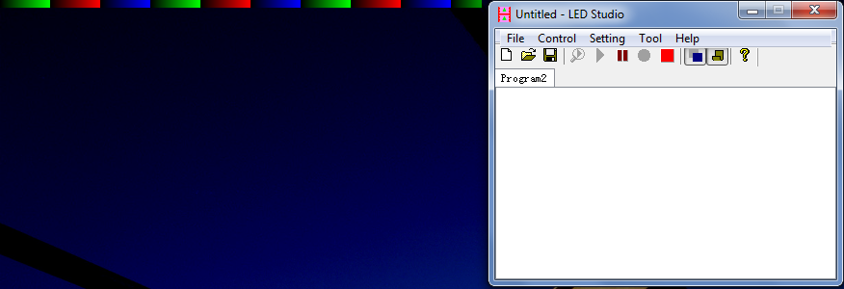
You can set the play window “Top display” so that any other programs won’t effect the play window.
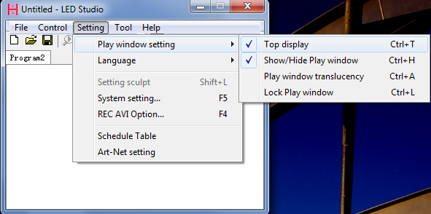
And the red indicator light on controller is flashing.
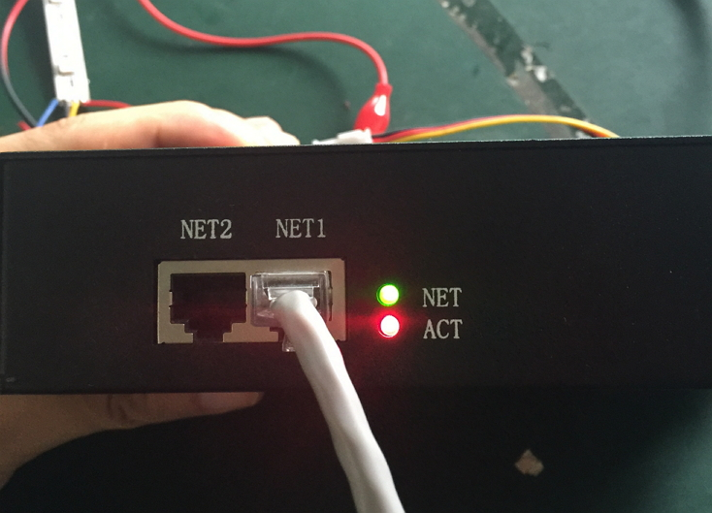
And the color on strips is changing as programmed in software(here i use WS2812 strips for display. And for WS2812, you need to connect GND, DAT to controller).
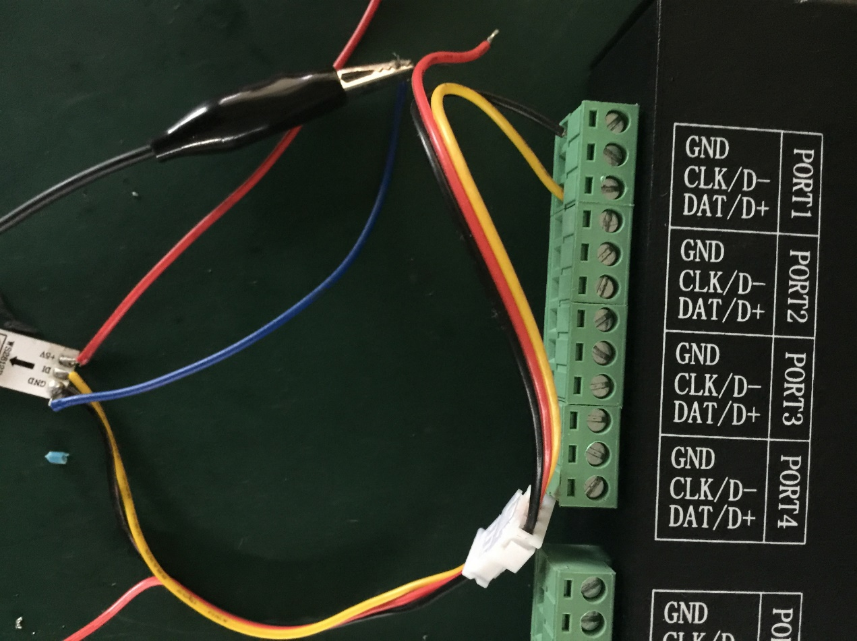

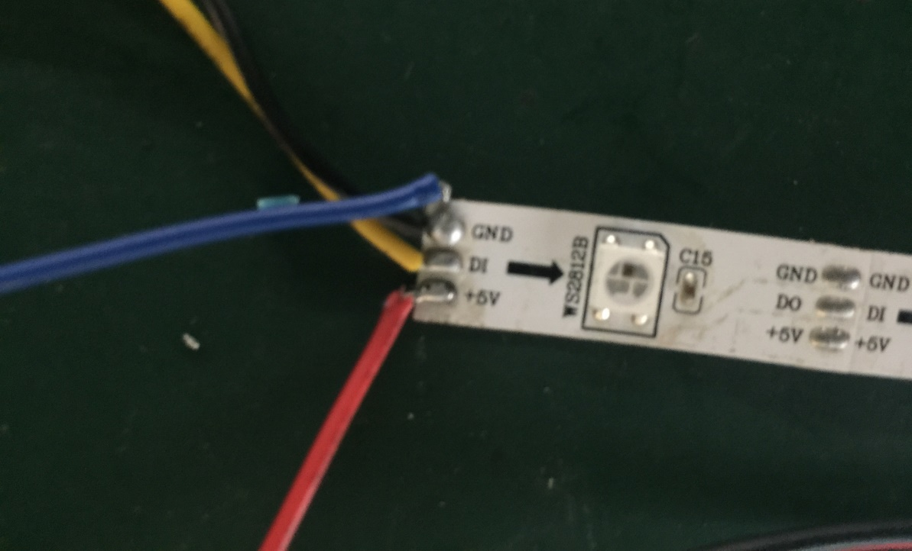
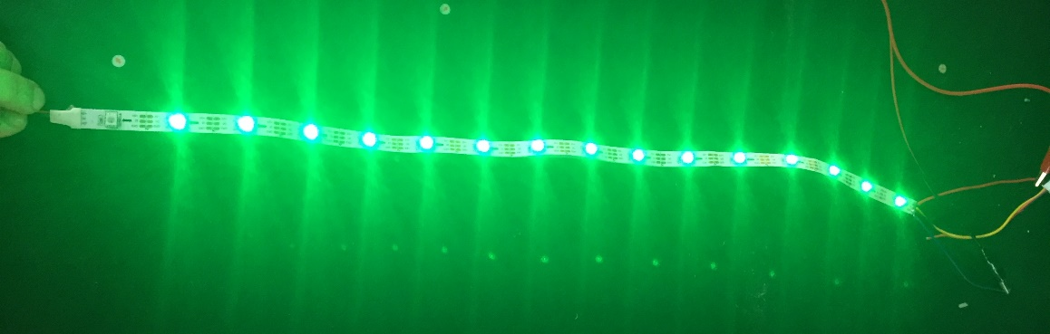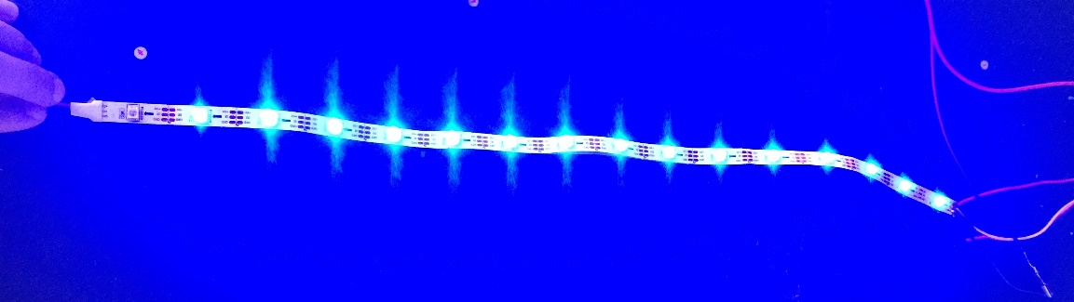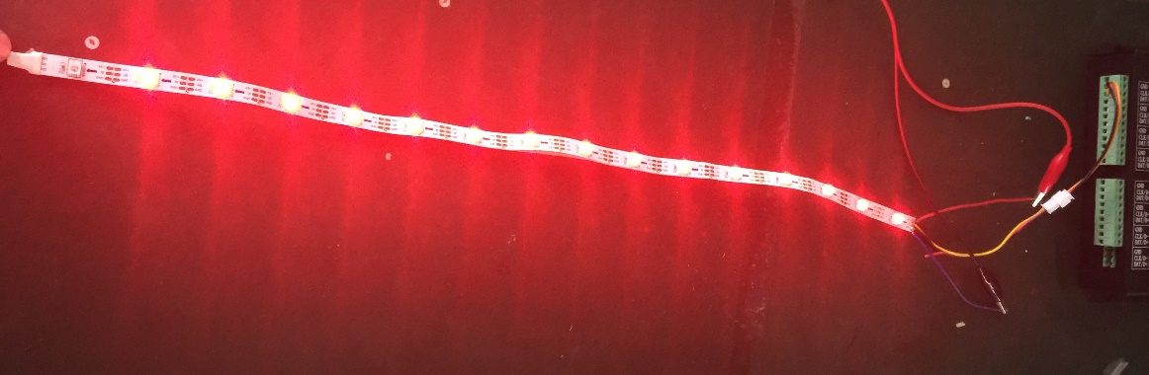
This is the end of this tutorial manual, many of the settings are just for display so you can have a quick knowledge of this software. There are many of the functions of this software aren’t introduced.

